- DECISION TREE
AIM
To implement a simple Decision Tree algorithm using Python to predict whether a student will Pass or Fail based on study hours and attendance.
OBJECTIVE
- To understand the concept of a Decision Tree.
- To use conditions for making decisions.
- To accept study hours and attendance as manual input.
- To predict the student's result.
ALGORITHM
- Start the program.
- Read the student's study hours.
- Read the student's attendance percentage.
- Check whether study hours are at least 5 and attendance is at least 75%.
- If true, display Pass.
- Otherwise, check whether study hours are at least 4 and attendance is at least 70%.
- If true, display Pass.
- Otherwise, display Fail.
- Stop the program.
FLOWCHART:
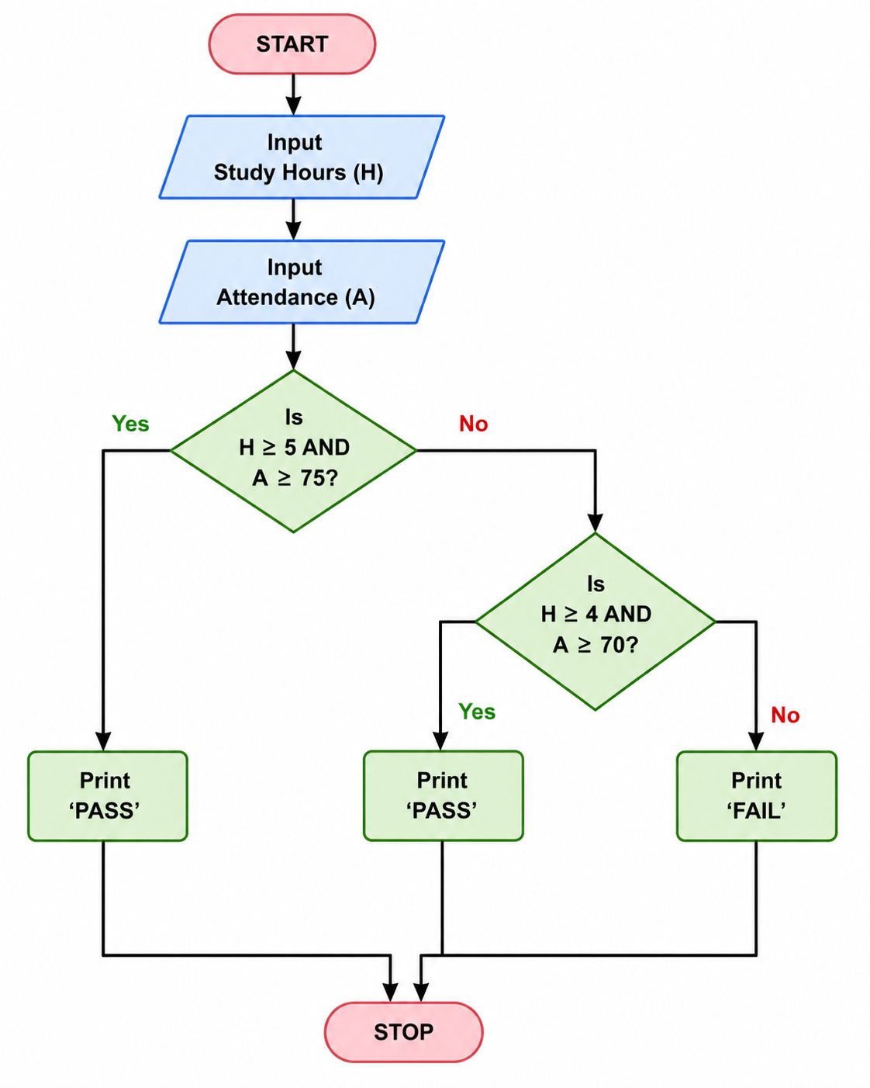
PYTHON CODE:
h = int(input("Enter study hours: "))
a = int(input("Enter attendance: "))
if h >= 5 and a >= 75:
print("Result: Pass")
elif h >= 4 and a >= 70:
print("Result: Pass")
else:
print("Result: Fail")
OUTPUT:
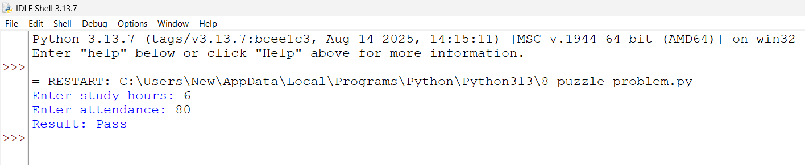
RESULT:
Thus, the Decision Tree-based program was successfully implemented in Python. It accepts study hours and attendance as manual inputs and predicts whether the student will Pass or Fail.

